FALLS NOTES 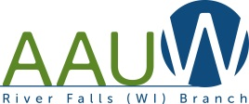
2017-18 Branch Officers
President:
Lorraine Davis 715-629-7392
ldavis4762@aol.com

President-Elect
Suzanne Hagen 715-425-1471
Suzanne.hagen.1@gmail.com

Co-Program VP:
Sue Danielson 715-425-9082
suzied40@hotmail.com

Co-Chairs Membership VP:
Suzanne Hagen 715-425-1471
Suzanne.hagen.1@gmail.com

Ruth Lee 715-425-7094
ruth.a.lee@icloud.com

Co-Secretaries:
Maureen Olle-LaJoie 715-222-7384
Maureen.olle-lajoie@uwrf.edu

Magdalena Pala 715-425-2613
Magdalena.e.pala@uwrf.edu

Treasurer:
Tina Kelly 715-307-4120
tk36698@gmail.com

PROGAM LEADERS

Public Policy Chair:
Barbara Peterson 715-425-5638
lbpeters@dishup.us

International Rel.:
Yolanda Dewar 651-459-3843
yolandadewar@gmail.com

Historian:
Jeanne Zirbel 715-425-2669
jeanne.zirbel@gmail.com

Newsletter:
Cheryl Maplethorpe 715-307-8036
cheryl.kay.maplethorpe@gmail.com

Book Sale Chairs:
Jane Matthews 715-425-2442
jjmatthews@Baldwin-telecom.net

Science Essay Contest:
Jean Johnson 715-425-7826
jeanjohnson@gmail.com

Sue Danielson 715-425-9082
suzied40@hotmail.com

Jeanne Zirbel 715-425-2669
jeanne.zirbel@gmail.com

University Liaison:
Maureen Olle-LaJoie 715-222-7384
Maureen.olle-lajoie@uwrf.edu

Scholarship:
Jeanne Zirbel 715-425-2669
jeanne.zirbel@gmail.com
AAUW-River Falls, WI aauwrf@gmail.com
Branch Newsletter February 2019

Next regular meeting will be March 12 - Regular Meeting and Women’s History Month presentation in conjunction with the River Falls Public Library. There will also be a presentation of the Role Equity Award. Ruth Bader Ginsberg film to be shown and discussed

This is open to the public, so invite anyone interested in hearing about this interesting presentation.

PRESIDENT’ S COLUMN
Lorraine Davis, Branch President

State Convention
The AAUW Wisconsin State Convention will be held Friday, April 26 and Saturday, April 27 at the Lake Lawn Resort in Delavan. Registration begins at 2 on Friday and sessions at 3. Thus far, speaker topics will include Title IX, Non Traditional Career Education for Women, Preventing Human Trafficking and Best Branch Practices. Please consider this in your spring plans. Travel funds will be available for this purpose.

Caveat: In the newsletter Cheryl Maplethorpe, our esteemed newsletter editor, has put together a current schedule of events for the year. Please note that times and places are different from other years and these may not be final since as a group, we are nothing if not flexible. Thus, I encourage you to look at future communications carefully.

Kendra Morgan will be the new administrator for our AAUW branch Facebook Page. We had some difficulties with our old page so the best solution was to create a new page with

the URL:https://www.facebook.com/AAUW.RiverFalls . Please "like it." Also, if you have any events or information which are relevant please send your postings to moke1202@outlook.com.

Thank you, Kendra, for assuming this responsibility.

Also, we continue to work on making our Facebook page effective and for that we need everyone’s support. If you have things to share, contact Kendra Morgan moke1202@outlook.com
We have a new Facebook page. https://www.facebook.com/AAUW.RiverFalls
If you have not done so already, please "LIKE" the page by clicking at the top left side under the title.

BRANCH MEETING MINUTES
Maureen Olle-LaJoie and Magdalena Pala, Co-Secretaries

State Convention is April 26-27 in Lake Geneva.

MEMBERSHIP NOTES
Suzanne Hagen, Vice-President Membership
New Members:

FINANCE REPORT
Tina Kelly, Finance Chair

Many of our Branch members contribute a great deal to our community. If you know of any members who have been recognized for their achievements, let Magdalena Pala (magdalena.e.pala@uwrf.edu), our secretary, know and she will send a letter of congratulations on behalf of AAUW. Let's celebrate one another.

CARDS FOR SALE

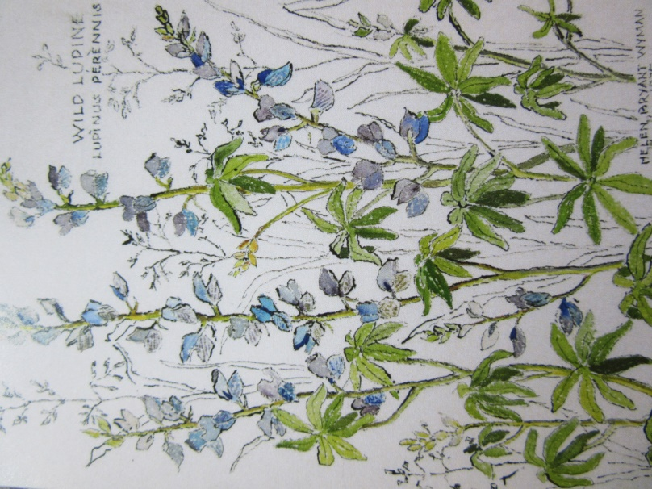
We have reissued notecards recreating the pen and ink drawings of past member, Helen B. Walker.

The new cards are of two of Helen Wyman's flower prints and are packaged in groups of eight.

They are available from Suzanne Hagen for $10.00.

A great gift!!!! A great support for AAUW efforts!!!!

ETHEL JOHNSON MEMORIAL
Submitted by Jean Johnson, Committee Chair of The Ethel Johnson Memorial Fund

The Ethel Johnson Memorial honors a woman dedicated to learning. AAUW wishes to remember Ethel for her many roles of service to our organization and the community. Her life is an example of what education and a spirit of giving can inspire in all of us. The fund will be used for grants that promote literacy, such as books for the food shelf or the public school back pack program. By sustaining this memorial, AAUW continues the values by which Ethel lived as a teacher, mentor, traveler, and friend.
Please send your monetary support to Tina Kelly, W9908 State Rd 35. Hager City WI 54014 or donate at our monthly AAUW meetings.
MEMBERSHIP NOTES
Suzanne Hagen, Vice-President Membership

Directory Update and Corrections – Dec. 11, 2018
Add as member renewal:
Murray, Lois (1992) 715-426-4778
Email: loidmuttsy@yahoo.com
1210 Golf View Drive
River Falls, WI 54022
B.S., B.A., University of Wisconsin-River Falls, Accounting
J.D., University of Minnesota, Law

New Member
Catherine Flowers
Address: 1738 Bennett St., River Falls, WI 54022
Phone: 651-329-3215
Email: artemesia25@gmail.com

Lorraine Davis: Phone number – 715-629-7392
Lorraine Peitso: Email – rcpeitso@gmail.com
Karen Stimeling: Delete B.S., Mankato State University, Elementary Education
Legislative Contacts, p. 20: Delete Kathleen Vinehout as District 31 senator. Jeff Smith will be incoming senator in 2019. Current contact information: 715-600-3703; info@togetherwithjeff.com. No Madison office phone or location available as yet.

INTERNATIONAL ISSUES
Yolanda Dewar, Chair

River Falls Branch: 2018-19 CALENDAR OF EVENTS – SUBJECT TO CHANGE
Monthly meetings are usually the second Tuesday of each month September to May with business meetings at 6:30 and programs open to the public at 7:00 at the River Falls Public Library. Exceptions are noted.
September 5 – City Sampler at UWRF, 11-1 pm

September 11 - Regular Meeting: COMMUNITY ROOM at the First National Bank, 104 E Locust Street, 6:00 Pot Luck Dinner, our business meeting at 6:30 PM, program presentation at 7:00 by our NCCWSL delegates, Jillisa Solberg and Temitope Abiodun

Early September – Book donation barrels placed in Family Fresh, Dick’s Grocery store and County Market in Hudson.

October 6 - Sorting of book donations, 9-noon - place TBD

October 29 (Monday) – Regular Meeting: 6:00 promptly at the River Falls Library. 6:30– Presentation by Craig Dudnick about Alice Tregay, unsung heroine of the Civil Rights Movement. Film and Discussion.

October 11 - BOOK SALE - October 11, 12, 13 and October 17, 18, 19, 109 North Main Street, River Falls

November 6 – Election Day

November 11 – Sunday Moose Lodge Breakfast Fund raiser

November 13 - Regular Meeting: Speaker, Madeline Uraneck, Wisconsin Educator and author of How to Make a Life about her friendship with a Tibetan family.

December 7 – Deadline for Middle School Science Essay contest

December 11 - Regular Meeting and Holiday Auction at Suzanne Hagen’s House, 2464 Golf View Dr. Bring a meatless appetizer or cookies to share. Starts at 6:30.

January 26, 2018 (Saturday 1 p.m.) – Regular meeting and STEM presentation with Science and Math Essay Awards at the River Falls Library. Katharine Hagen will be speaking about her career in biochemistry.

February 12 - Regular Meeting at 5:01 at Junior’s (to take advantage of HAPPY HOUR). Grace Coggio and Krista Cleary will help us learn about Radical Civility.

March 12 - Regular Meeting and Women’s History Month presentation in conjunction with the River Falls Public Library. There will also be a presentation of the Role Equity Award. Ruth Bader Ginsberg film to be shown and discussed

April 2 - Equal Pay Day

April 9 – Annual Meeting, Election of Officers, Program is a presentation by Agnes Ring, Executive Director of the Family Resource Center of St. Croix Valley.

April 13– 2019 STEM Girls in SCIENCE

April 14 – Equal Pay Day

April 26-27 - State AAUW Convention in Lake Geneva, Wisconsin

May 14 – Installation and Celebration 5:00 Wine Tasting Fund Raiser, 6:30 Pot Luck Dinner at Suzanne Hagen’s House, 2464 Golf View Dr. with a 5 - 6:30 wine tasting for those who would like to participant.

June 10 – 100th anniversary of the ratification of the 19th Amendment by Wisconsin

AAUW’s MISSION STATEMENT
AAUW advances equity for women and girls through advocacy, education, philanthropy, and research.

AAUW’s VALUE PROMISE
By joining AAUW, you belong to a community that breaks through educational and economic barriers so that all women have a fair chance. AAUW empowers all women and girls to reach their highest potential.

VISION STATEMENT
AAUW empowers all women and girls to reach their highest potential.

DIVERSITY STATEMENT
AAUW values and seeks a diverse membership. There shall be no barriers to full participation in this organization on the basis of gender, race, creed, age, sexual orientation, national origin, disability, or class.

